**Linear regression model – Walmart sales**

**Regression**

The simple use of regression is to use data to analyse relationships between features and variables(L.H,2007,p.1). Within machine learning the aim of regression is to establish a model that predicts a numeric and quantifiable value. It is known to be a statistical method that allows you to relate a dependent variable to one or more independent variables, making it easy to expound for most. There are 2 types of regression, univariate regression and multivariate regression. Univariate analysis tends to focus on analysing a single data component or variable to reach a conclusion, whereas multivariate analysis examines several variables to assimilate the connections and interactions between them (Dremio,n.d). For instance, in this report a linear regression model has been utilised to forecast the weekly sales obstacles Walmart has faced due to socio-economic factors and seasonal trends.

Regression works by conducting the data on the variables in a question. For example, to predict a house price based on its size, you would use x (the house size) as the independent variable and y (the price) as the dependent variable. Price = a+b x Size would be the outcome, where and is the y intercept and b is the slope.

Furthermore, it can be used in many different scenarios that impact our day-to-day life. Healthcare organizations will use regression to predict patients' outcomes. This approach benefited researchers to investigate the relationship between various factors and visual acuity outcomes in patients with diabetic macular oedema undergoing anti-VEGF therapy (Bzobsky et al.,2022). Linear regression was likely used to examine continuous outcomes, and logistic regression would have been applied to the probability of achieving a specific outcome.

A multiple linear regression model has been employed to analyse the relationship between the independent variables and dependent variable regarding the Walmart store. The aim of this is to predict the retail sales.

The data preparation step is shown in Figures 1, I preprocessed the data using Select Columns in Dataset and Normalize Data after importing the Walmart dataset. You can remove any independent variables with missing data by selecting specific columns in the select columns in dataset. The independent variable date has been removed from the dataset in this instance. As you can see, the majority of the data was NaN when previewing. As for normalized data, this component allows you to rescale the data to satisfy specific analysis requirements and enables numbers to run smoothly.

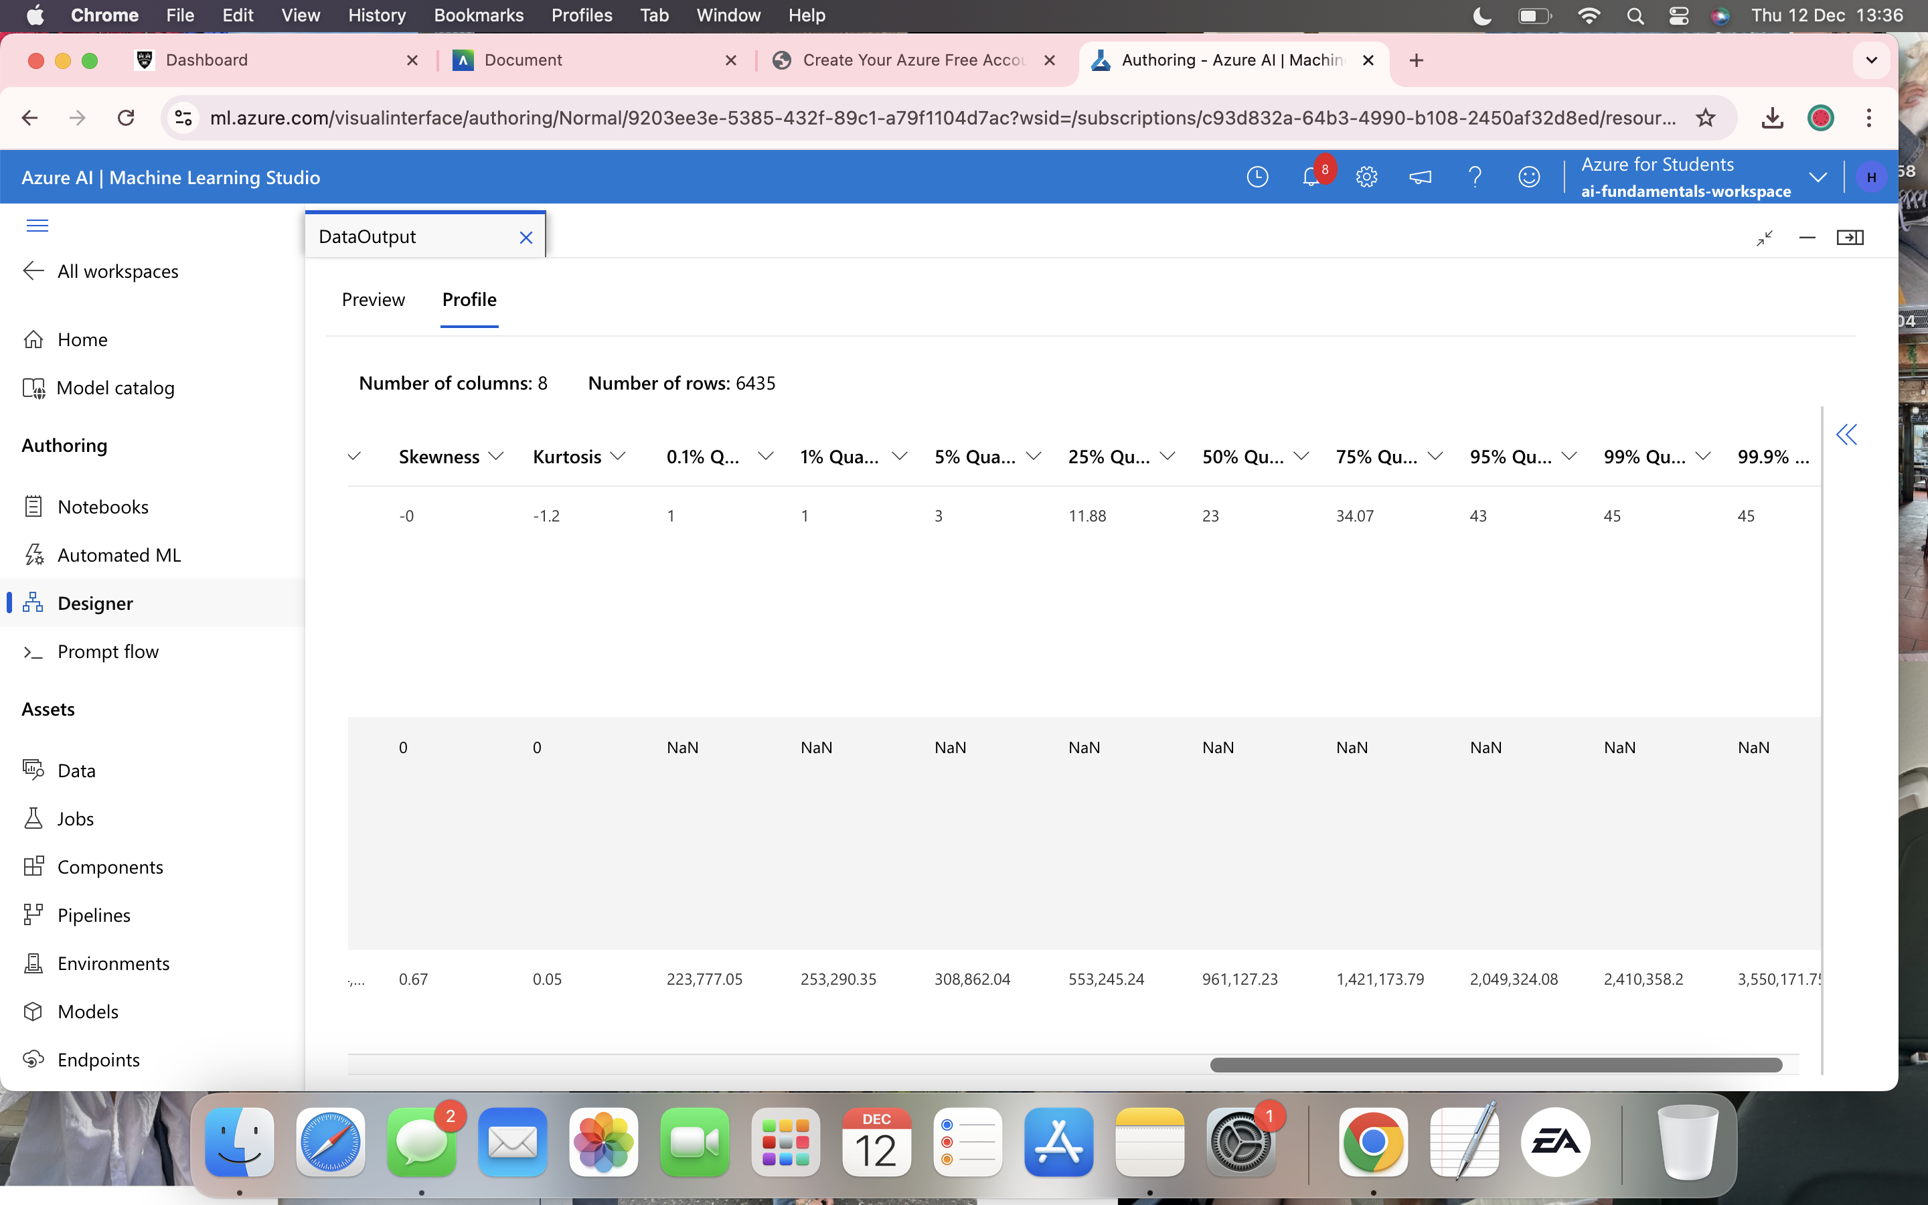

**Figures 1**

Figures 1.2 show the training pipeline procedure and the obtained outcome results of running the pipeline. Splitting the data gives you 70% of the data to train and test, as for the 30% it's used to see how well your model functions. I changed the label in the train model to weekly sales to receive a numeric value which I have trained using regression algorithm. The result obtained in this shows that model performance is weak since both RSA and RAE are high and the other values are low.

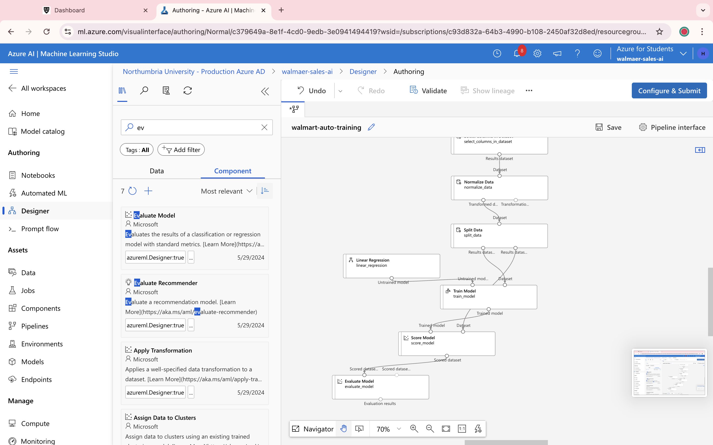

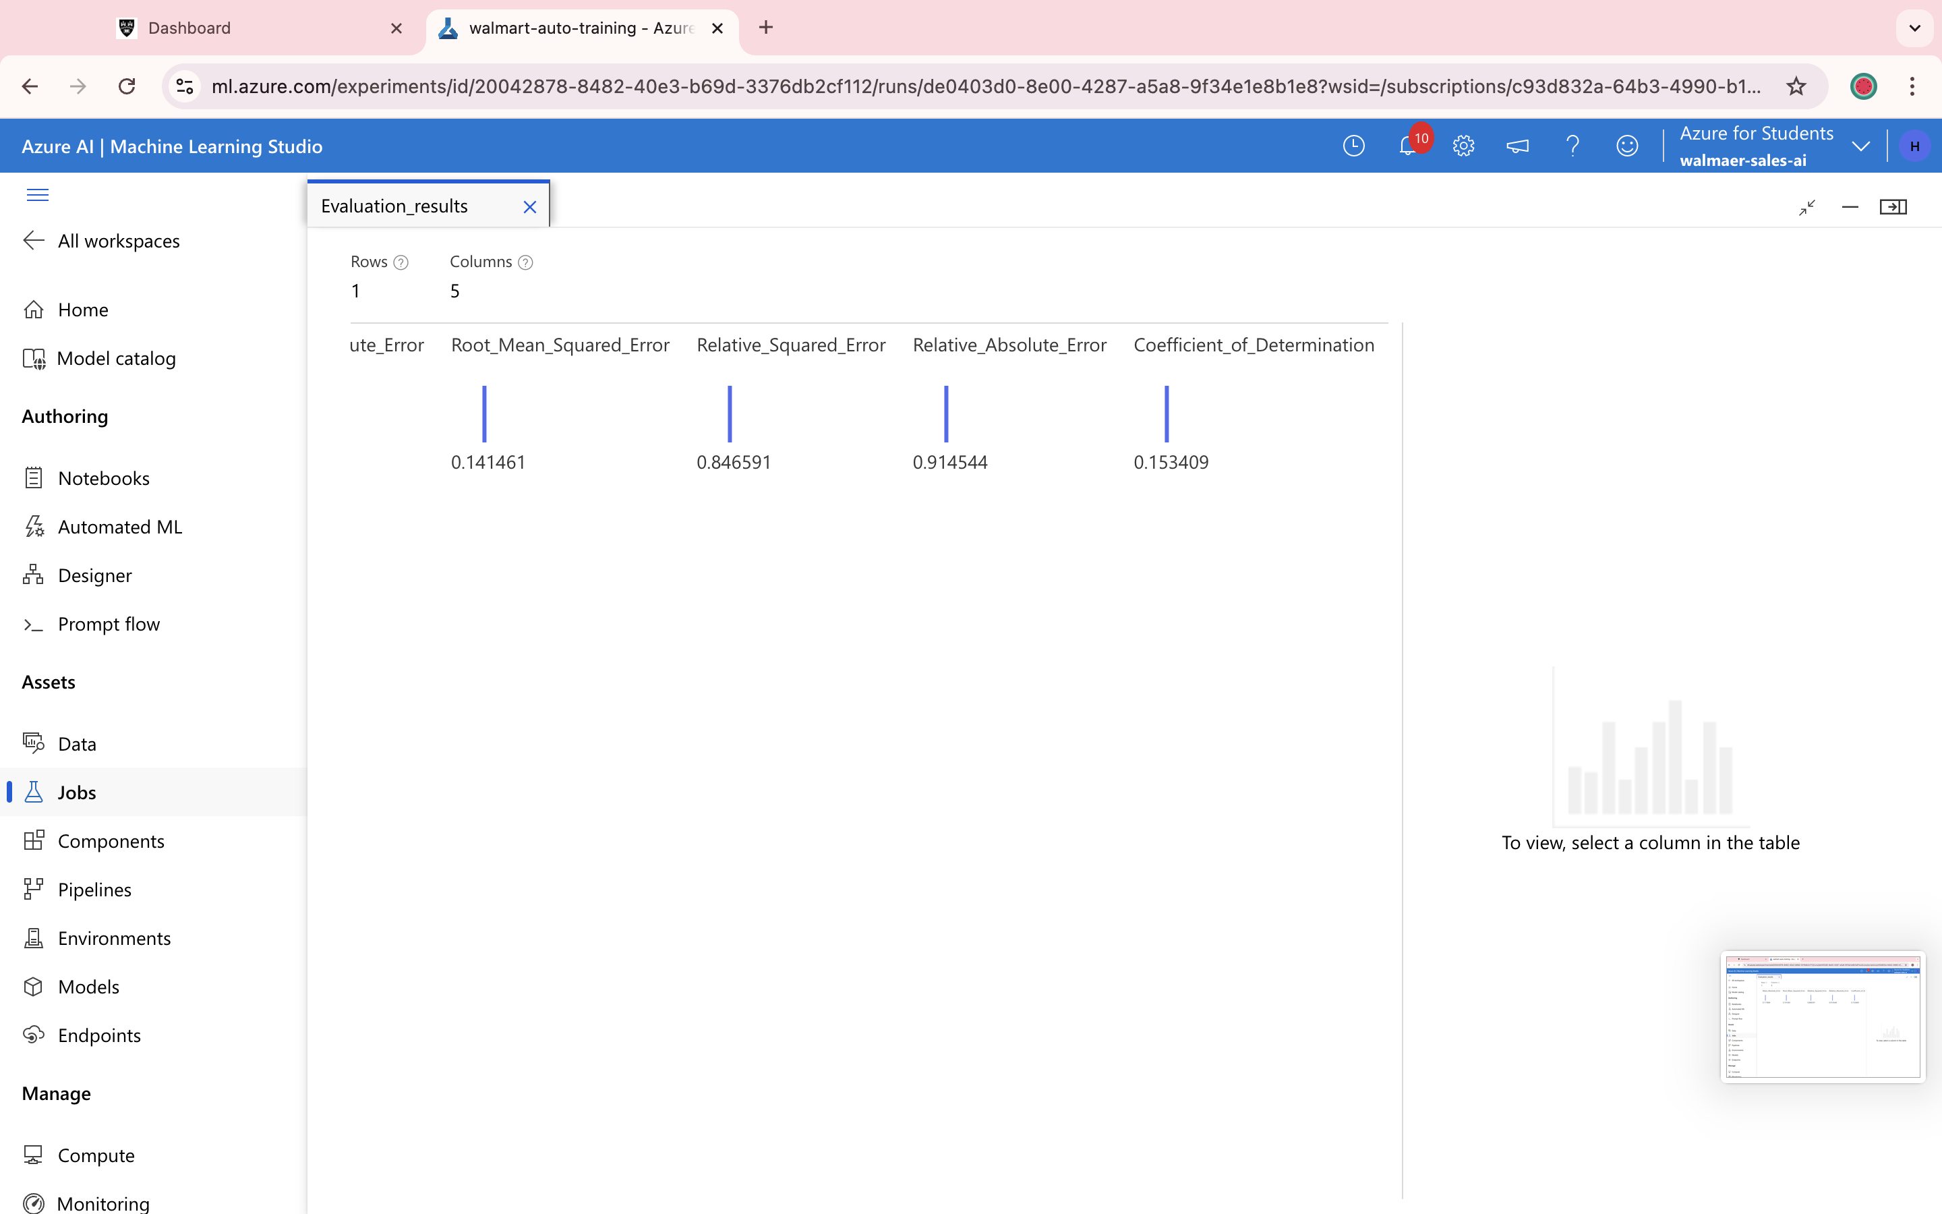

**Figures 1.2**

Figure 1.3 shows the pipeline inference which is an essential step when trying to provide predictions. Real time pipelines enable these predictions to occur with minimal latency. The results obtained below show three rows for predicated weekly sales with a value around 0.308. This suggests these are sample predications generated by trained machine learning. As retail sales do generally tend to vary widely. In the last screenshot, the column represents predicted sales and the predictions to actual values for data points but yet tends to miss larger deviations.

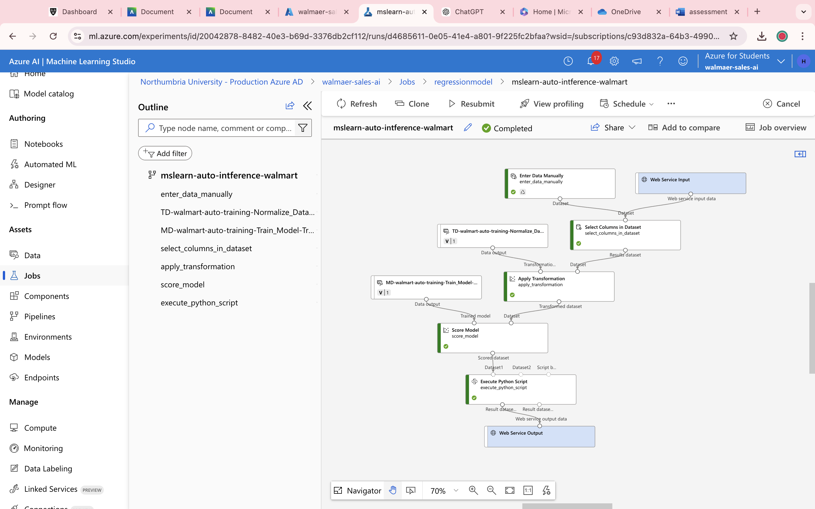

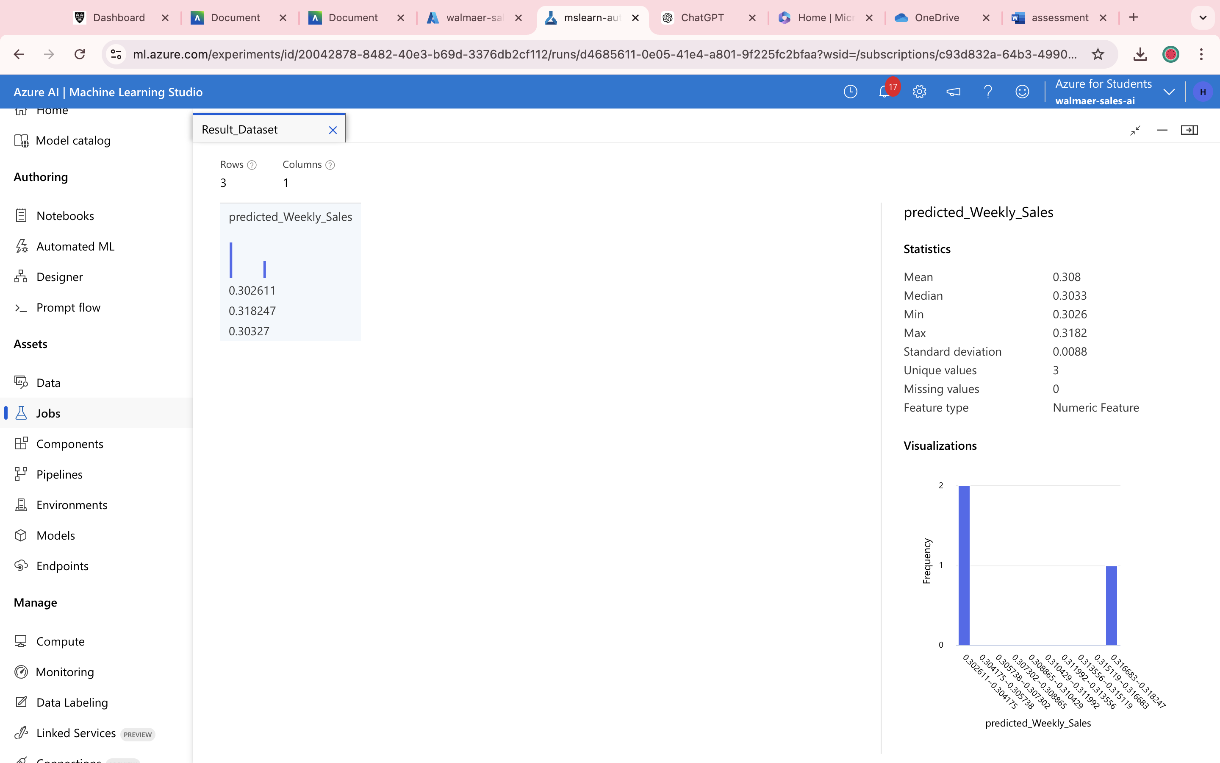

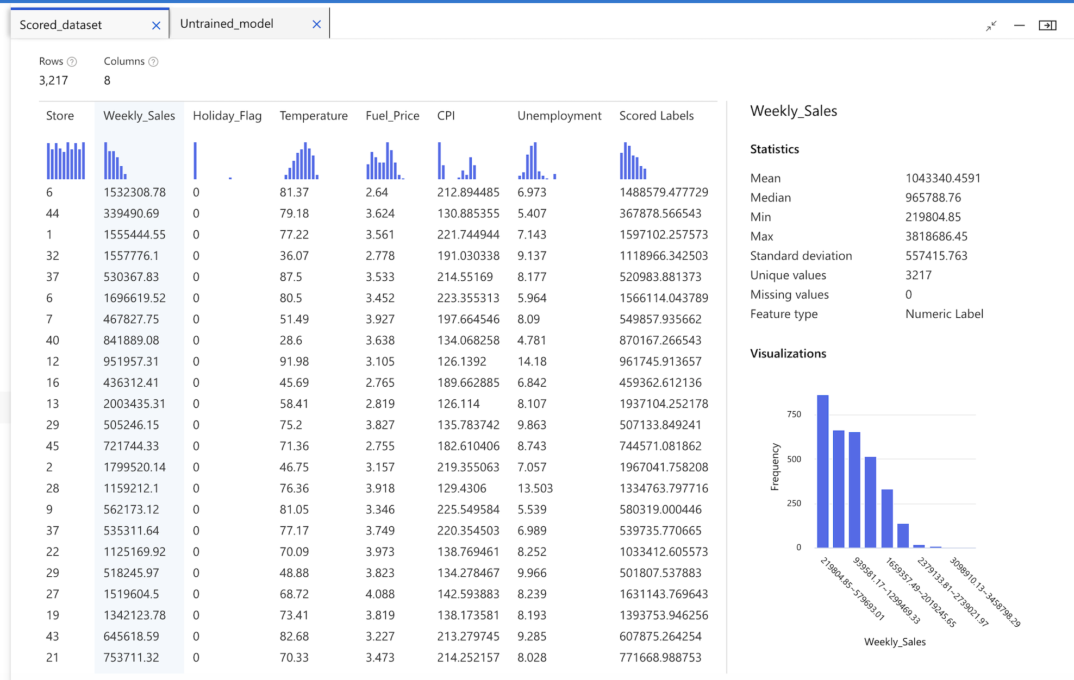

**Figure 1.3**

Retail sales are significantly impacted by socio-economic factors, including salaries, unemployment rates, and seasonal events. Walmart, which caters to consumers on limited finances, frequently experiences spikes in demand around holidays which increases during economic downturns. A greater understanding of trends influencing store performance and better sales predicted from including socioeconomic data, such as unemployment.

**Classification- Titanic**

Classification is a supervised machine learning method that uses a model to attempt to predict the right label for a given set of input data. In the classification process, the model is thoroughly trained on training data, assessed on validation data, and then used to make predictions on new, unseen data.

There are two types of classification models, Binary classification that divides input data into two categories such as "yes" or "no" that are mutually exclusive and multi-class classification where it predicts which class an input example belongs to by combining more than two mutually exclusive class labels.

When using machine learning for classification, the choice of classification model and performance metrics should be catered to certain objectives and contexts of the task. This model works by sorting data points into predefined groups (IBM, n.d).

Additionally, classification relies on specific objectives and data preparation to learn from labelled data and assign new data points to specified goals.

For instance, classification is often used in health care settings for cancer screening, in this case it is vital to priorities the negative predictive value to avoid false negatives that could indicate patients are cancer free (Black, Kueper and Williamson,2023). The NPV is calculated as part of the evaluation process.

Regression and classification are merely different from each other, classification predicts categorical groups such as spam whereas regression predicts continues numerical values such as temperature (Scribbr, n.d). There are variations from evaluation metrics to algorithm usage.

A predictive model that may recognise the characteristics that increased a person's odds of surviving the Titanic disaster has been developed using Microsoft Azure machine learning. This conclusion was reached using information including name, age, gender, etc. The pipeline process is illustrated in the images below.

Figure 1 shows the data preparation process using Select Columns in Dataset and Normalized Data. Within select columns in dataset the following data elements, passengerld, neme, sex, embarked and cabin were removed due to being NaN. The normalized data provided the transformed dataset where you can see that the data has been normalized to a common scale. As you can see key numericals have been scaled to smaller range (0-1), whereas ticket and pclass appear unchanged. This is now better suited for machine learning.

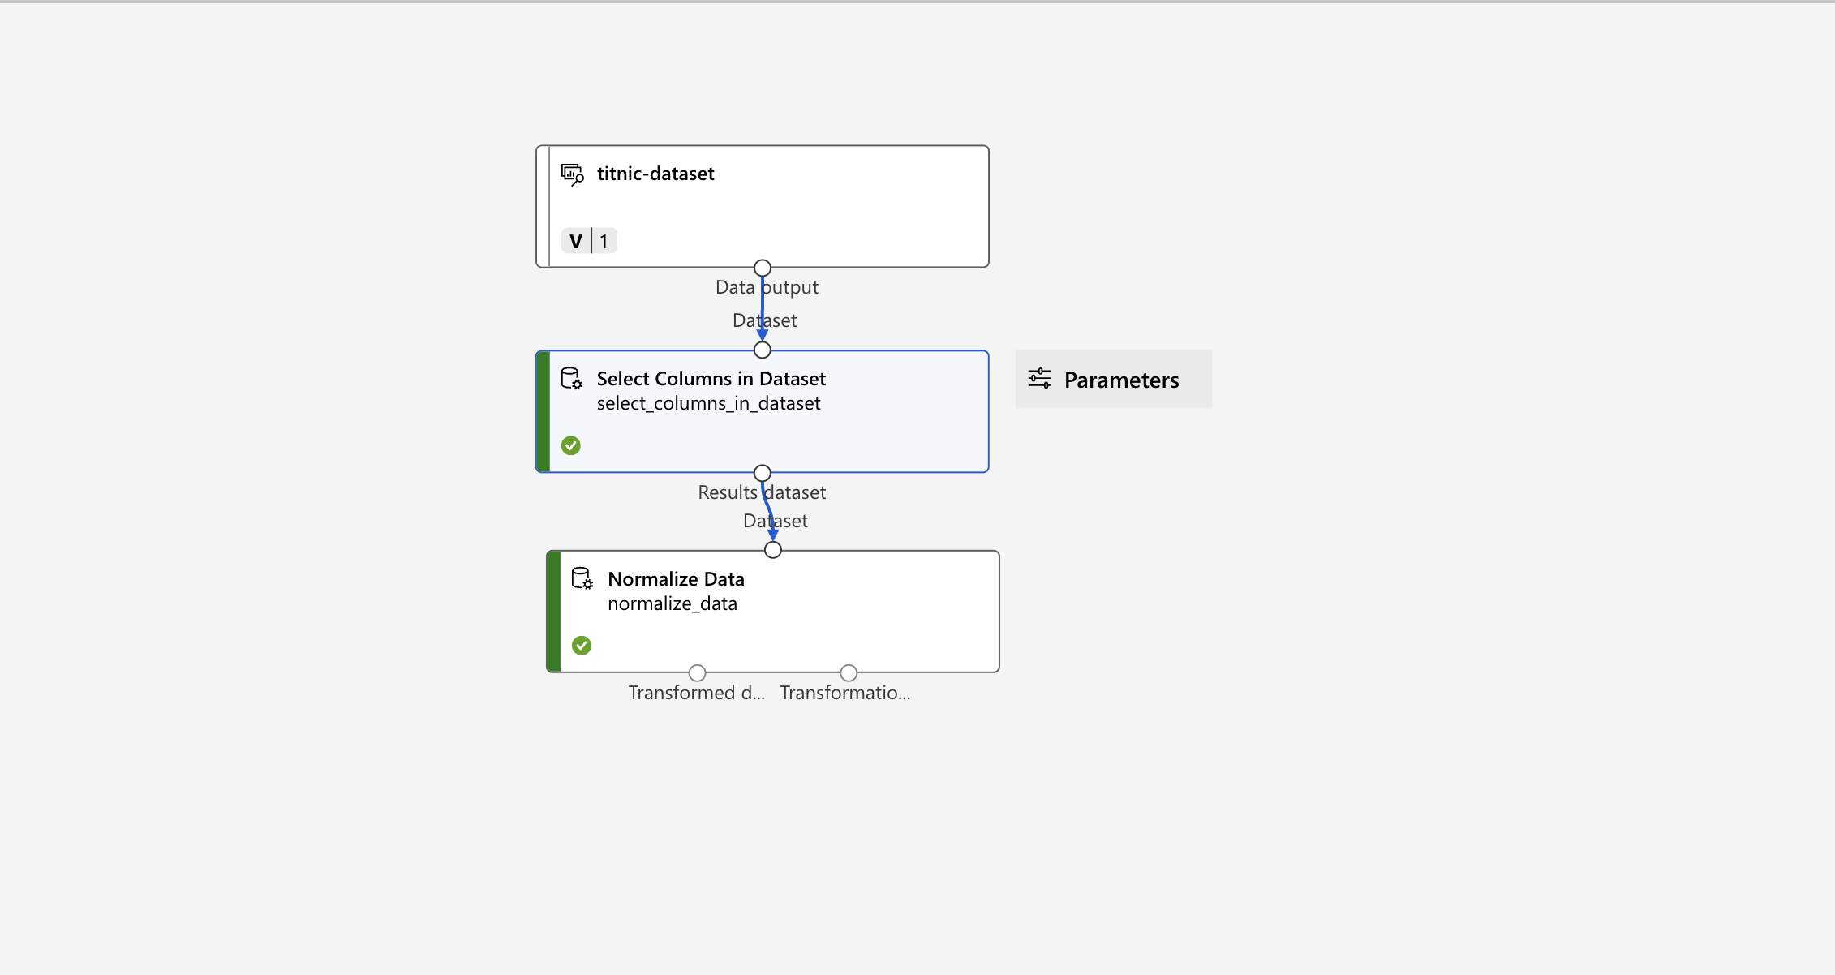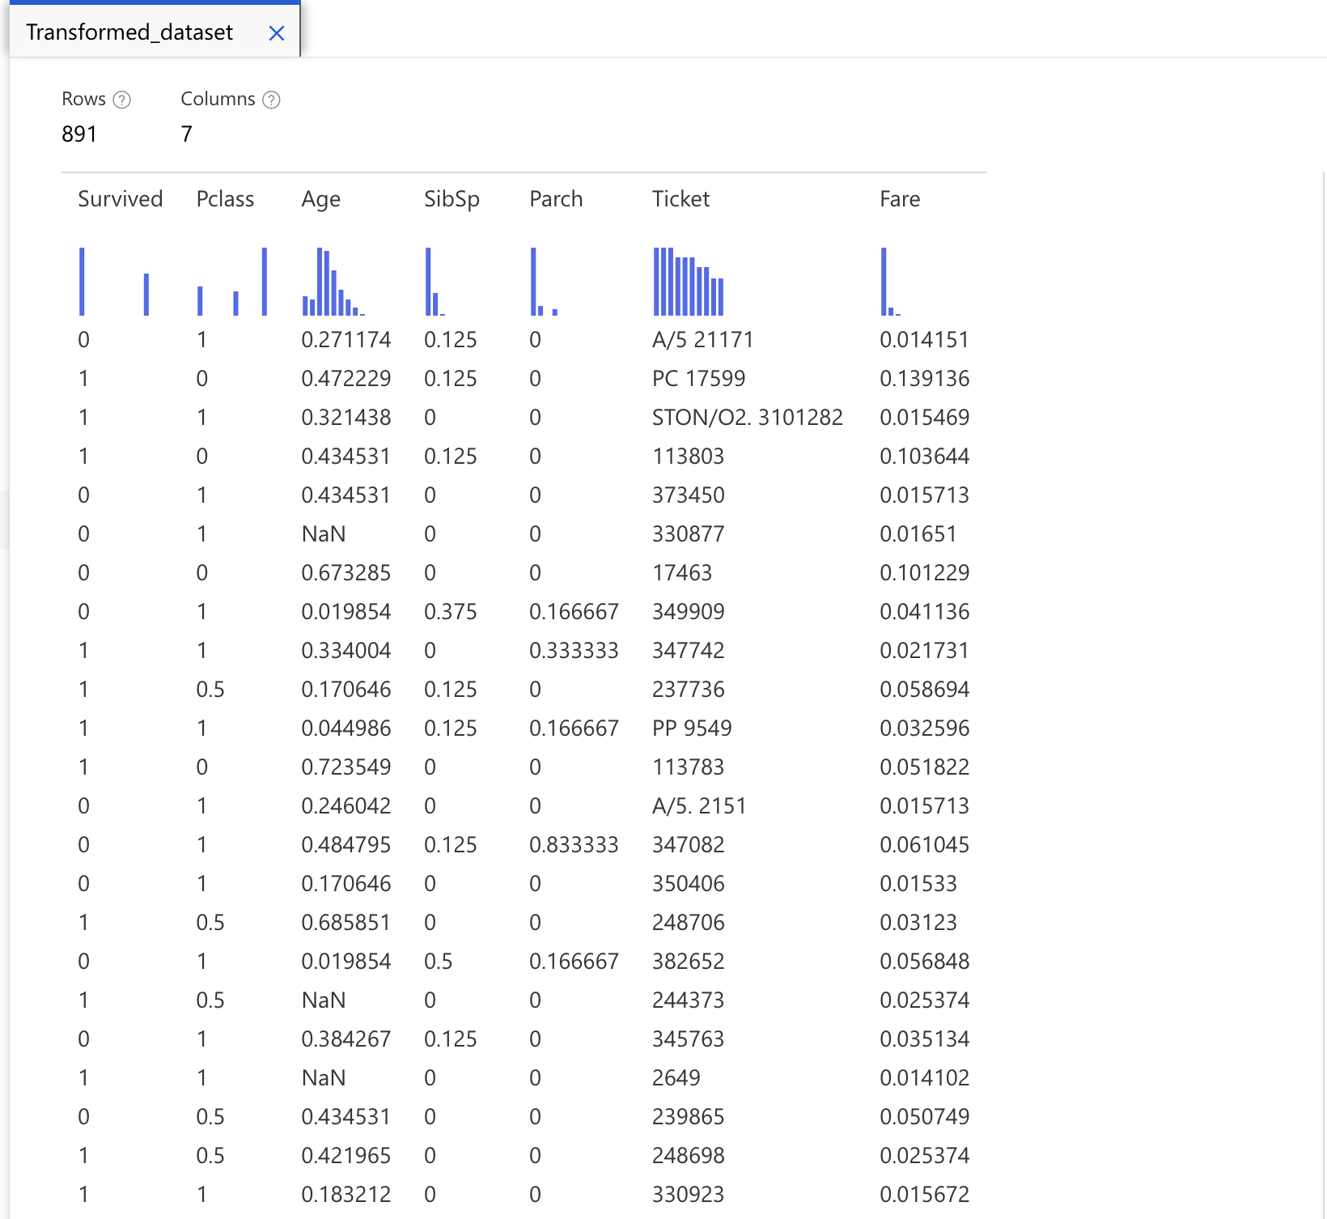

**Figure 1**

Figure 1.2 is the training models of the pipeline, the model we are trying to predict here is survival, so we remove the label survived from the train model. The results below give some insights into the chance of survival. Features like pclass, age, and fare seem to be influencing the probabilities and predictions. Label 1 with higher scored probabilities shows that passengers are more likely to have been predicted as survivors.

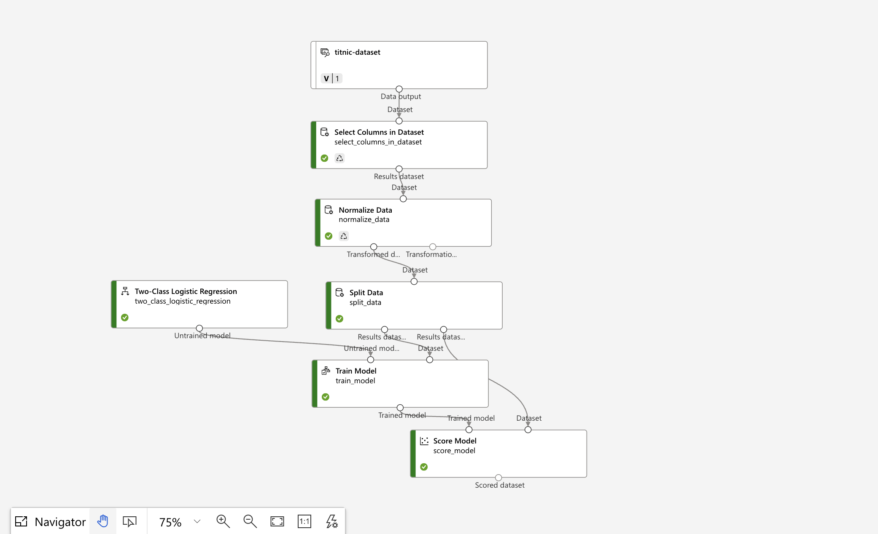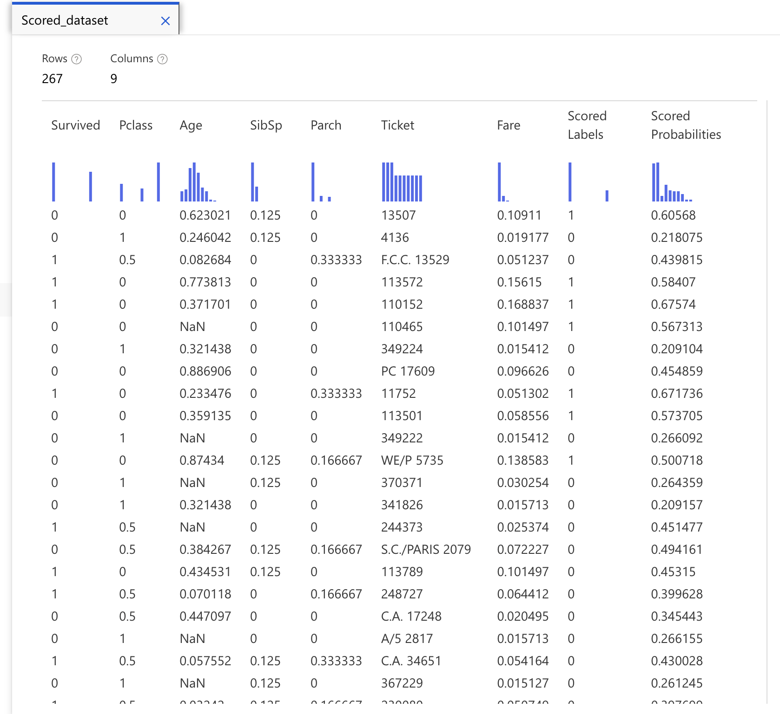

**Figure 1.2**

Figure 1.3 shows the validation stage of the pipeline; the image below is regarding the evaluation result.

Accuracy represents the proportion of total predictions that were correct (0.663). The model correctly predicted the outcome for 66.3% of cases. As for precision which indicates the proportion of positive predictions, 72.1% means the model predicted survival, it was correct in 72.1% of the cases.

Recall results measure the proportion of actual survivors, 37.6% suggests that the model is missing other true survivors and only identified 37.6% survivors. The F1 score balances the 2 metrics, it is moderate balances but yet struggles.

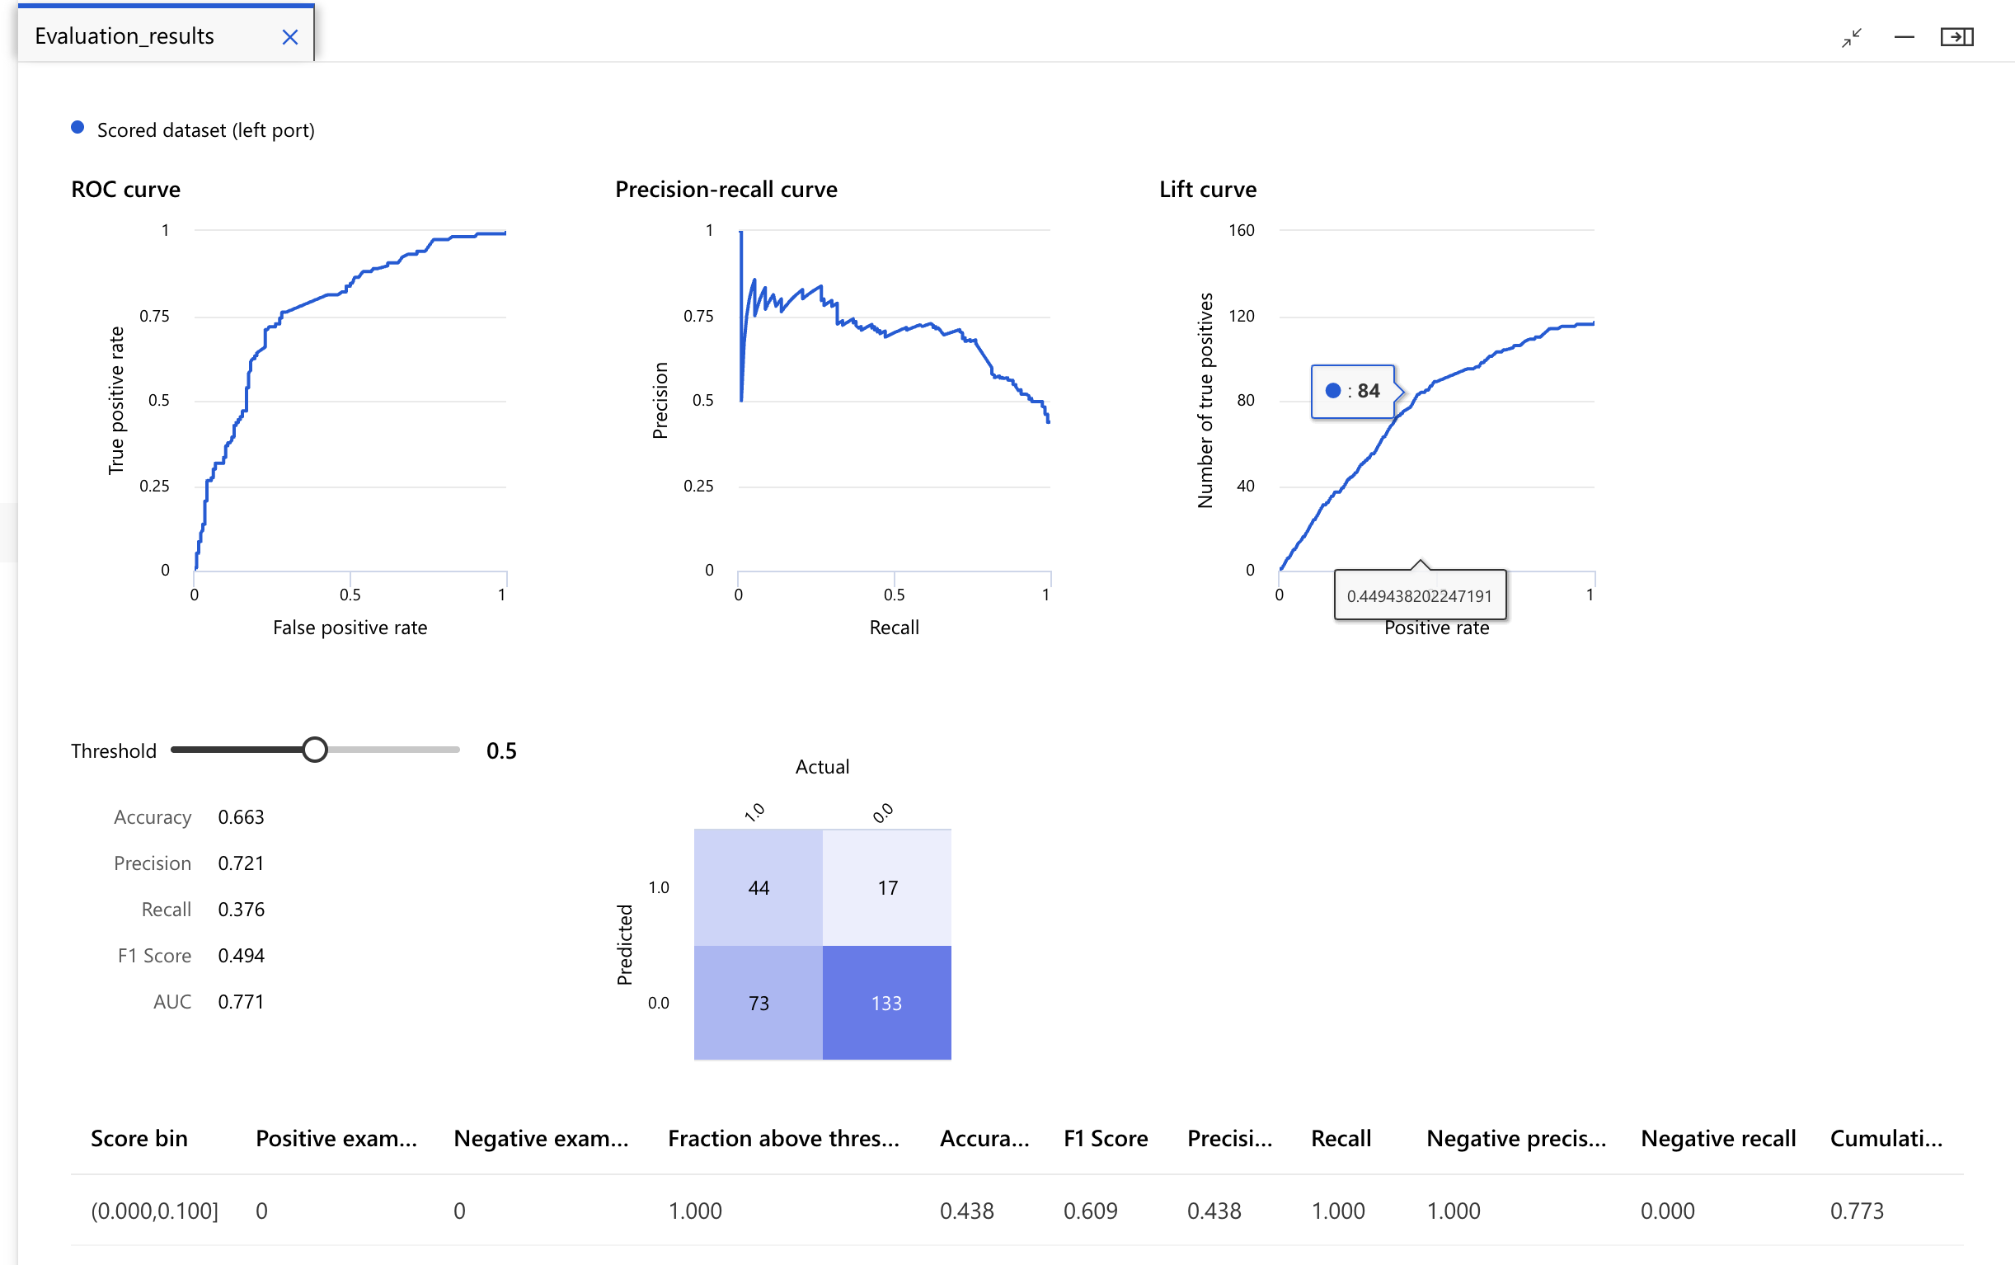

**Figure 1.3**

**Clustering-Iris Flower**

A form of unsupervised machine learning model called clustering divides observations into groups based on similarities points or data values. Also, because it does not train models using previously known label values, this kind of machine learning is unsupervised (GreeksforGeeks, n.d). Within clustering, the label is the cluster to which the observation is assigned based only on its features. Clustering is beneficial today as it is an efficient way to group individuals, behaviors, objects and more.

Clustering can be applied to different scenarios as Google Developers (n.d) suggests that clustering can be used for studies. For example, patients can report how many times per week they will experience certain symptoms and the severity of them, and this can allow researchers to use clustering analysis model to group patients with similar treatment responses into clusters. This will benefit researchers to understand what the baseline cause of certain symptoms is.

Clustering can also be applied to many different scenarios such as computer vision models/applications in which it can organise images and identify certain features within a group.

Conceptually clustering and classification are similar, but the training data lacks values that can be used to predict the class label. Classification tends to be a more complex process compared to clustering because it's a supervised learning approach as a specific label is provided by the machine. As for clustering, the machine extracts from provided data and does not need training (Javetpoint, n.d). Overall, both learning approaches contain their similarities and differences and are used to reach specific outputs and aims.

Using Microsoft azure machine learning, a clustering task has been completed where the dataset was used without the labels. The task is about the Iris flower dataset which is used in machine learning and consists of 150 samples from three iris species which measure 4 features each. The main goal is to explore the clustering results. The images below show the pipeline process of completing this task.

Figure 1 shows the preparation process of the dataset. The label was removed (Iris species) which was removed in the Select Columns in Dataset. This gave us 4 columns of the flower's sepal length, sepal; width, petal length and petal width. Clean Missing Data was used to handle missing or NaN values within the dataset where all the columns were included in this step. Normlised data was then used to ensure all data is to scale for the machine to handle it efficiently.

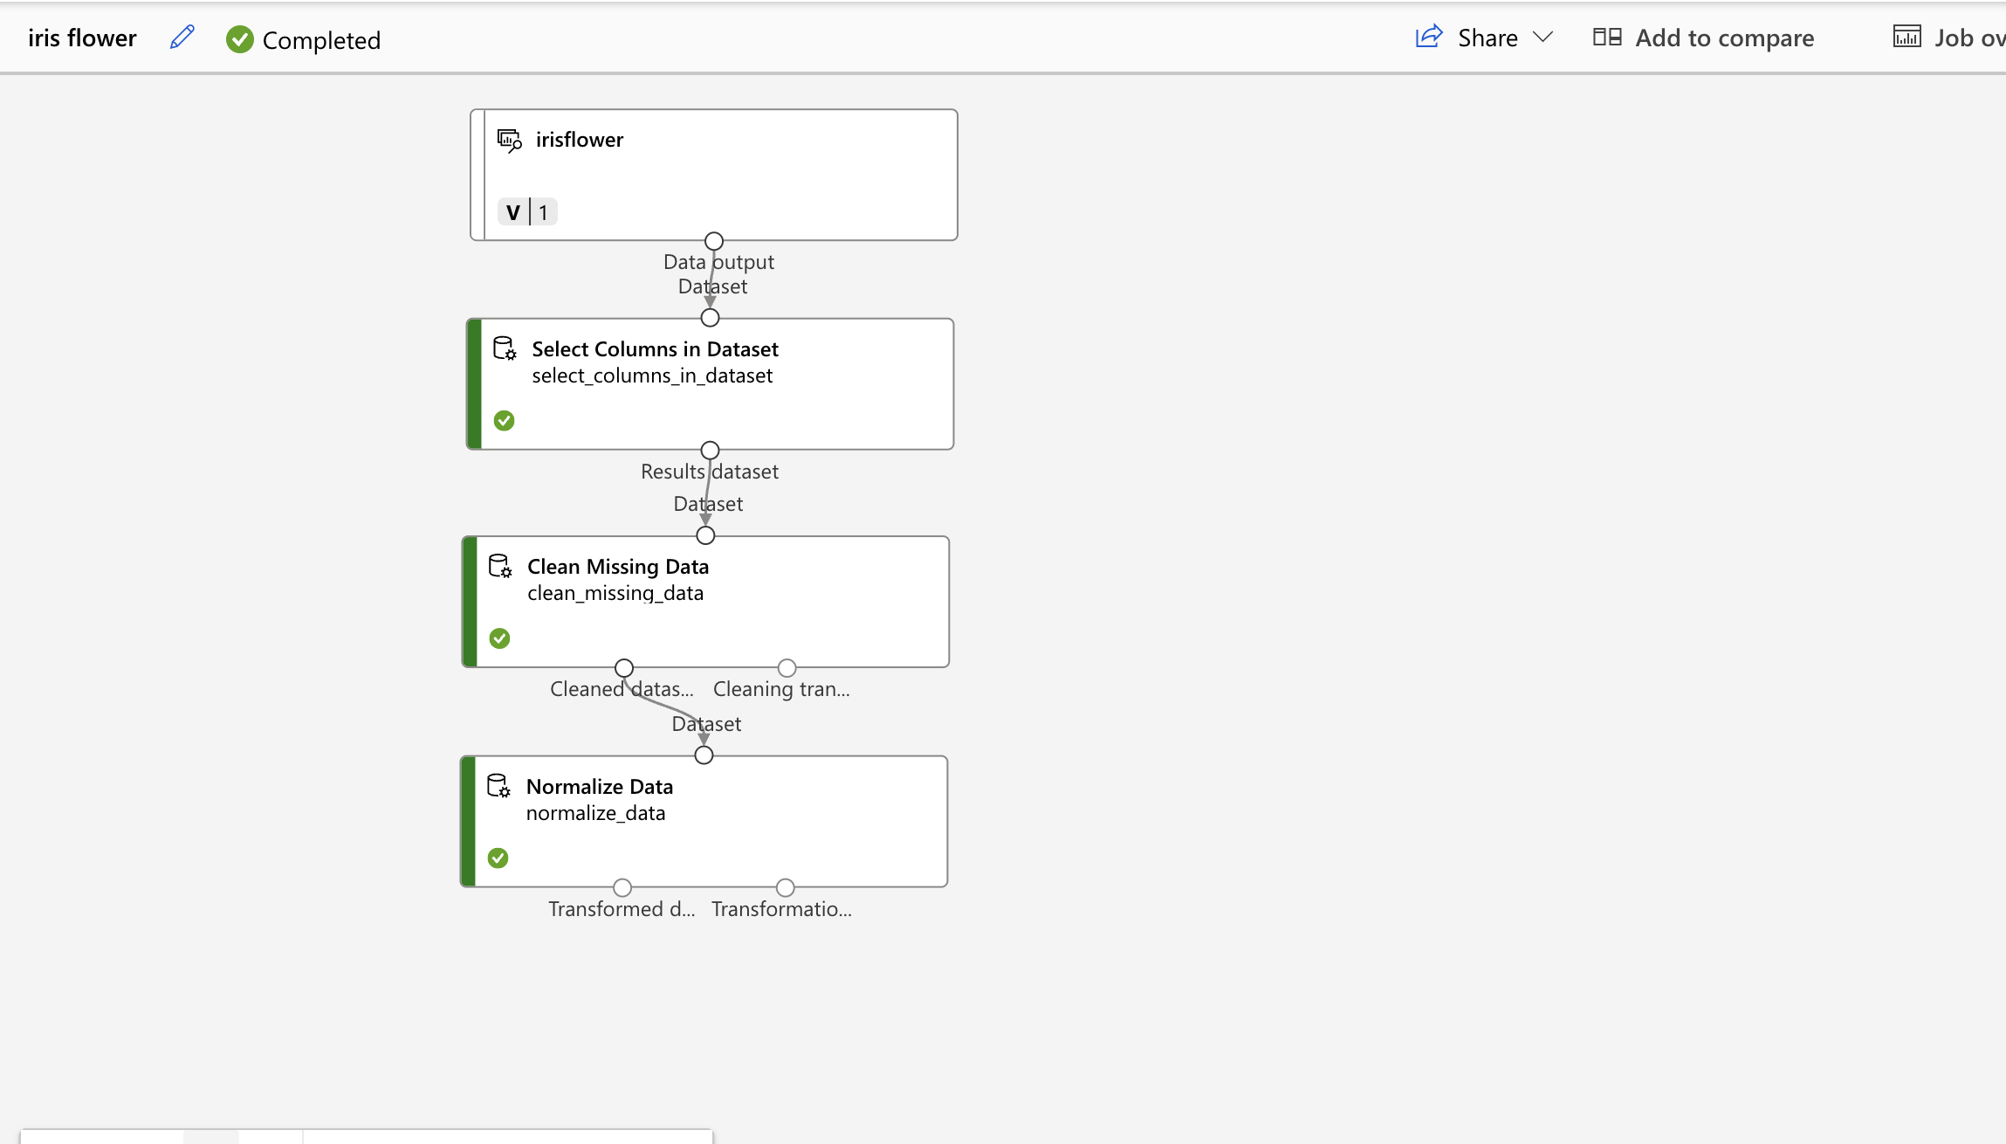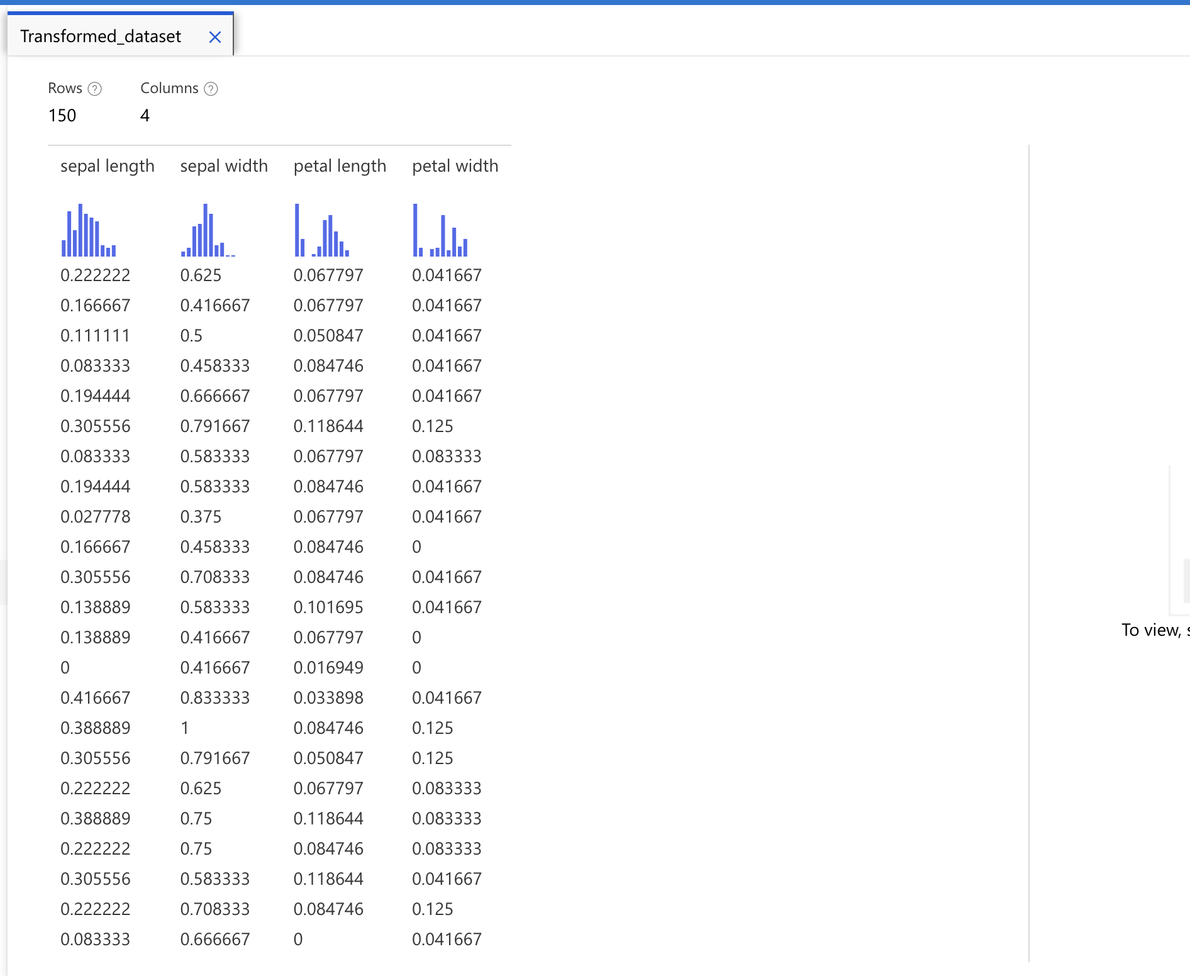

Figure 1

The figure below shows the training modules of the process, I used data splitting to divide my data to a 70% and 30% ratio. This is for training segments. The Training a clustering model is K-means which is a popular clustering algorithm which tends to work well for numerical data. The result has a few columns in which are important. The cluster assignments column shows which cluster each data point belongs to (0,1 or 2) As for distance to cluster Centre column, indicates how far each point is from the Centre of the respective clusters.

. 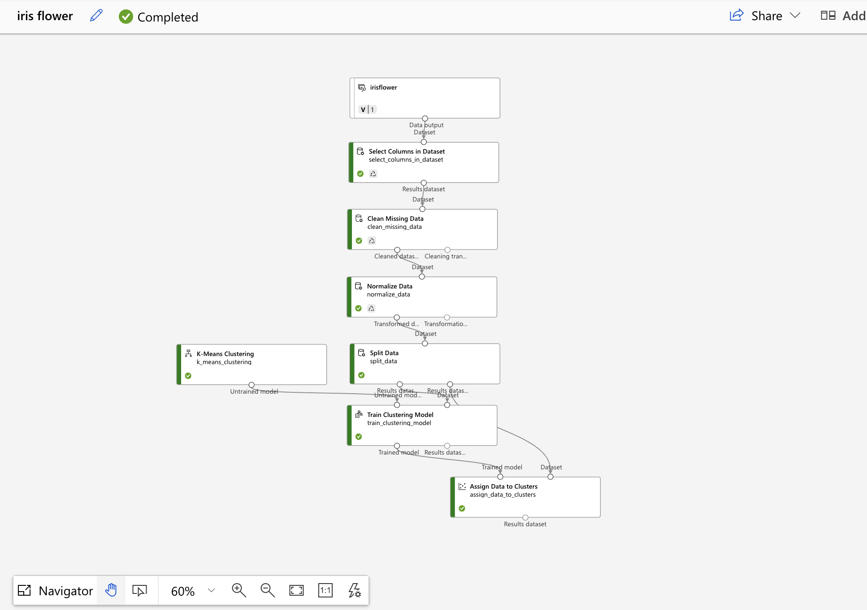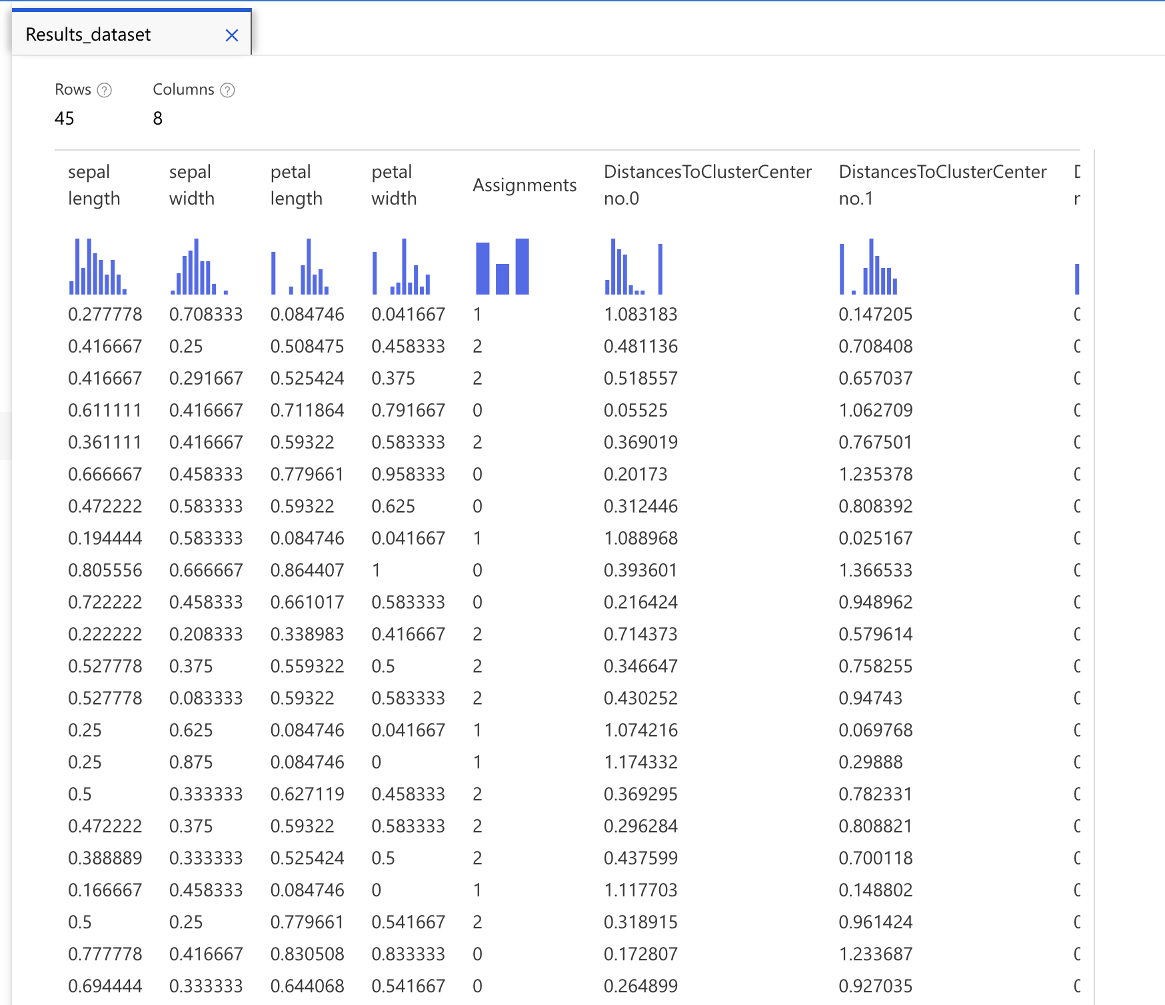

Figure 1.2

The figure below highlights the evaluated model of the pipeline, this provides valuable insights into the cluster quality. The metrics in the table suggest a few things. The average distance to other center shows on average how far data points each cluster are from the centres of other clusters. Usually, lower values indicate better separation between clusters. Therefore, cluster No.1 has the highest value of 0.758 implying it could be closer to other cluster centres or potentially overlap. The disruption of points across clusters looks balanced but does suggest that cluster N0.1 may be underpopulated. Overall, cluster No.1 is the most compact and well defined, as for cluster No.0 it seems to spread with higher maximal distance. According to the result we can see the evulation metrics suggest that the clustering is fairly good.

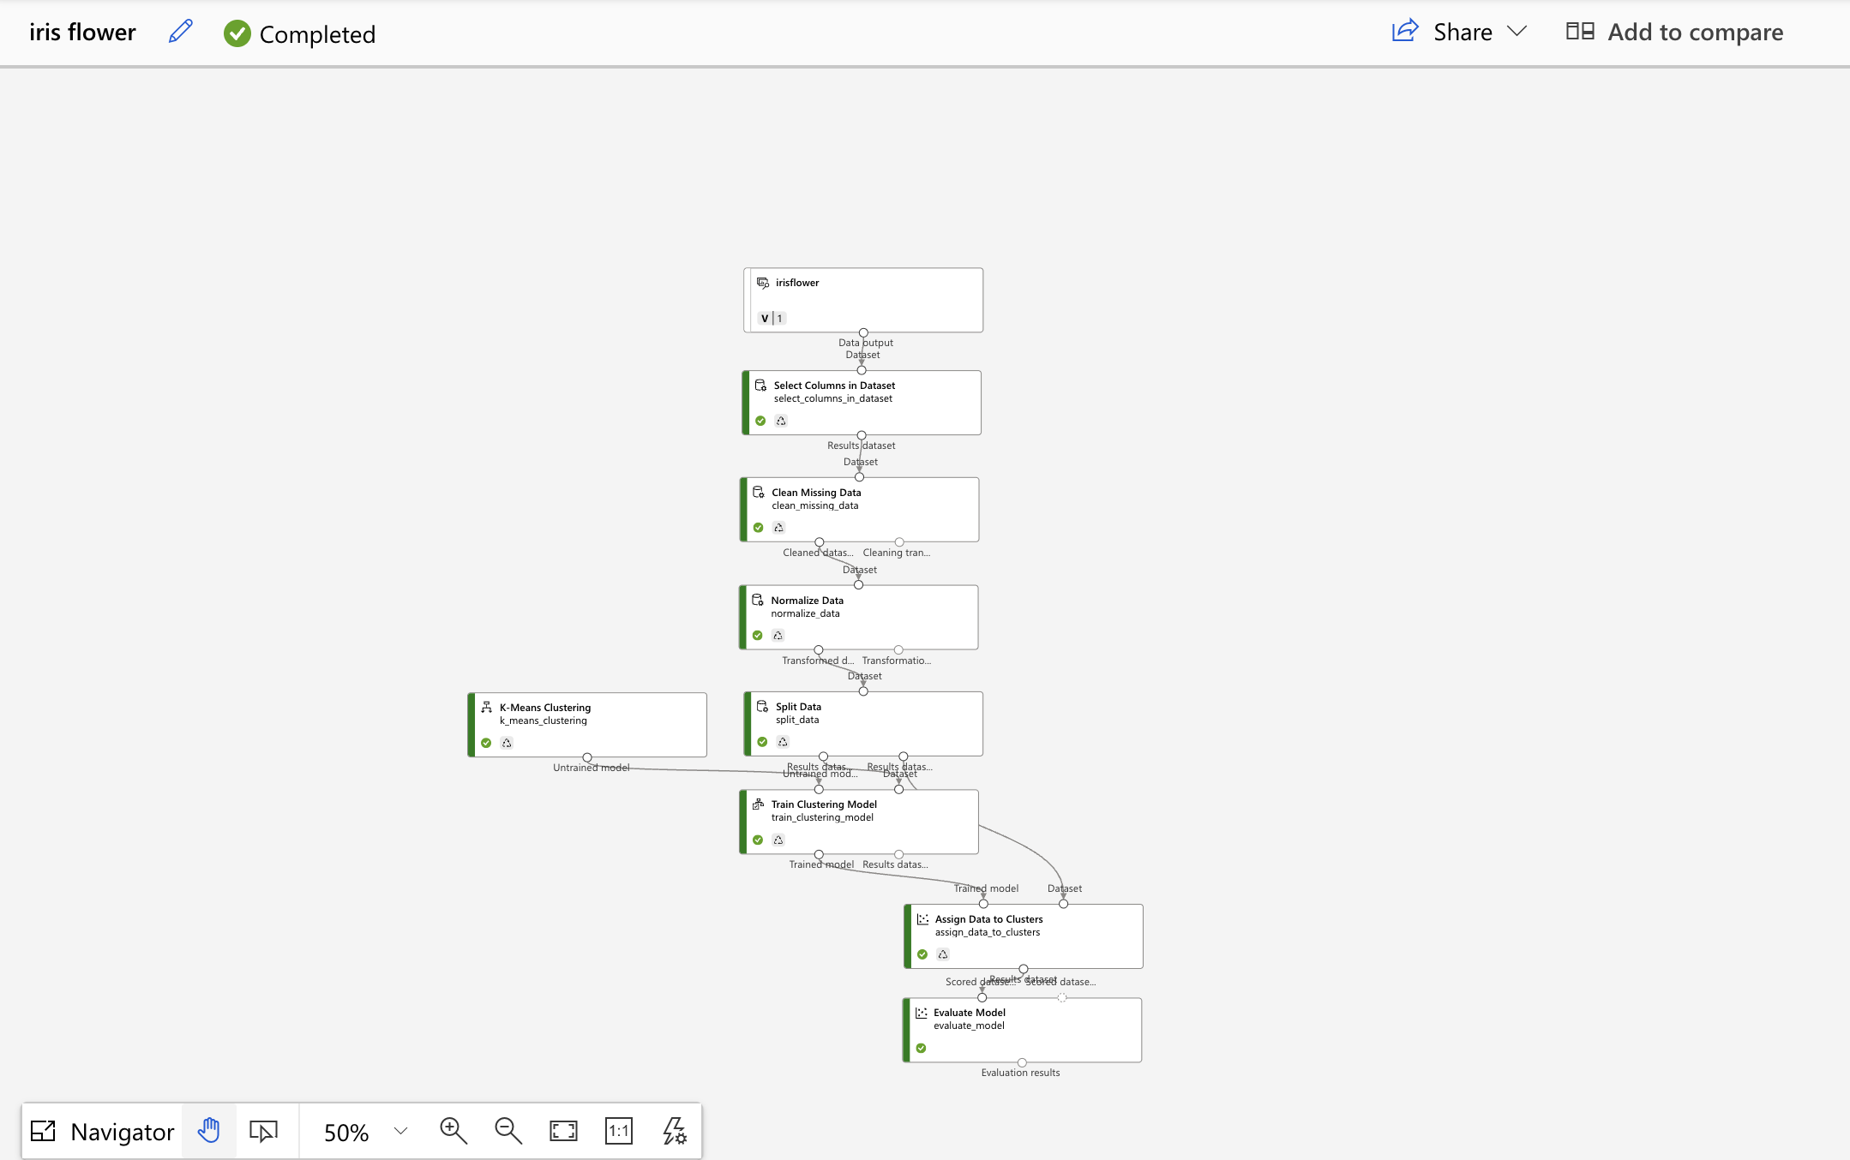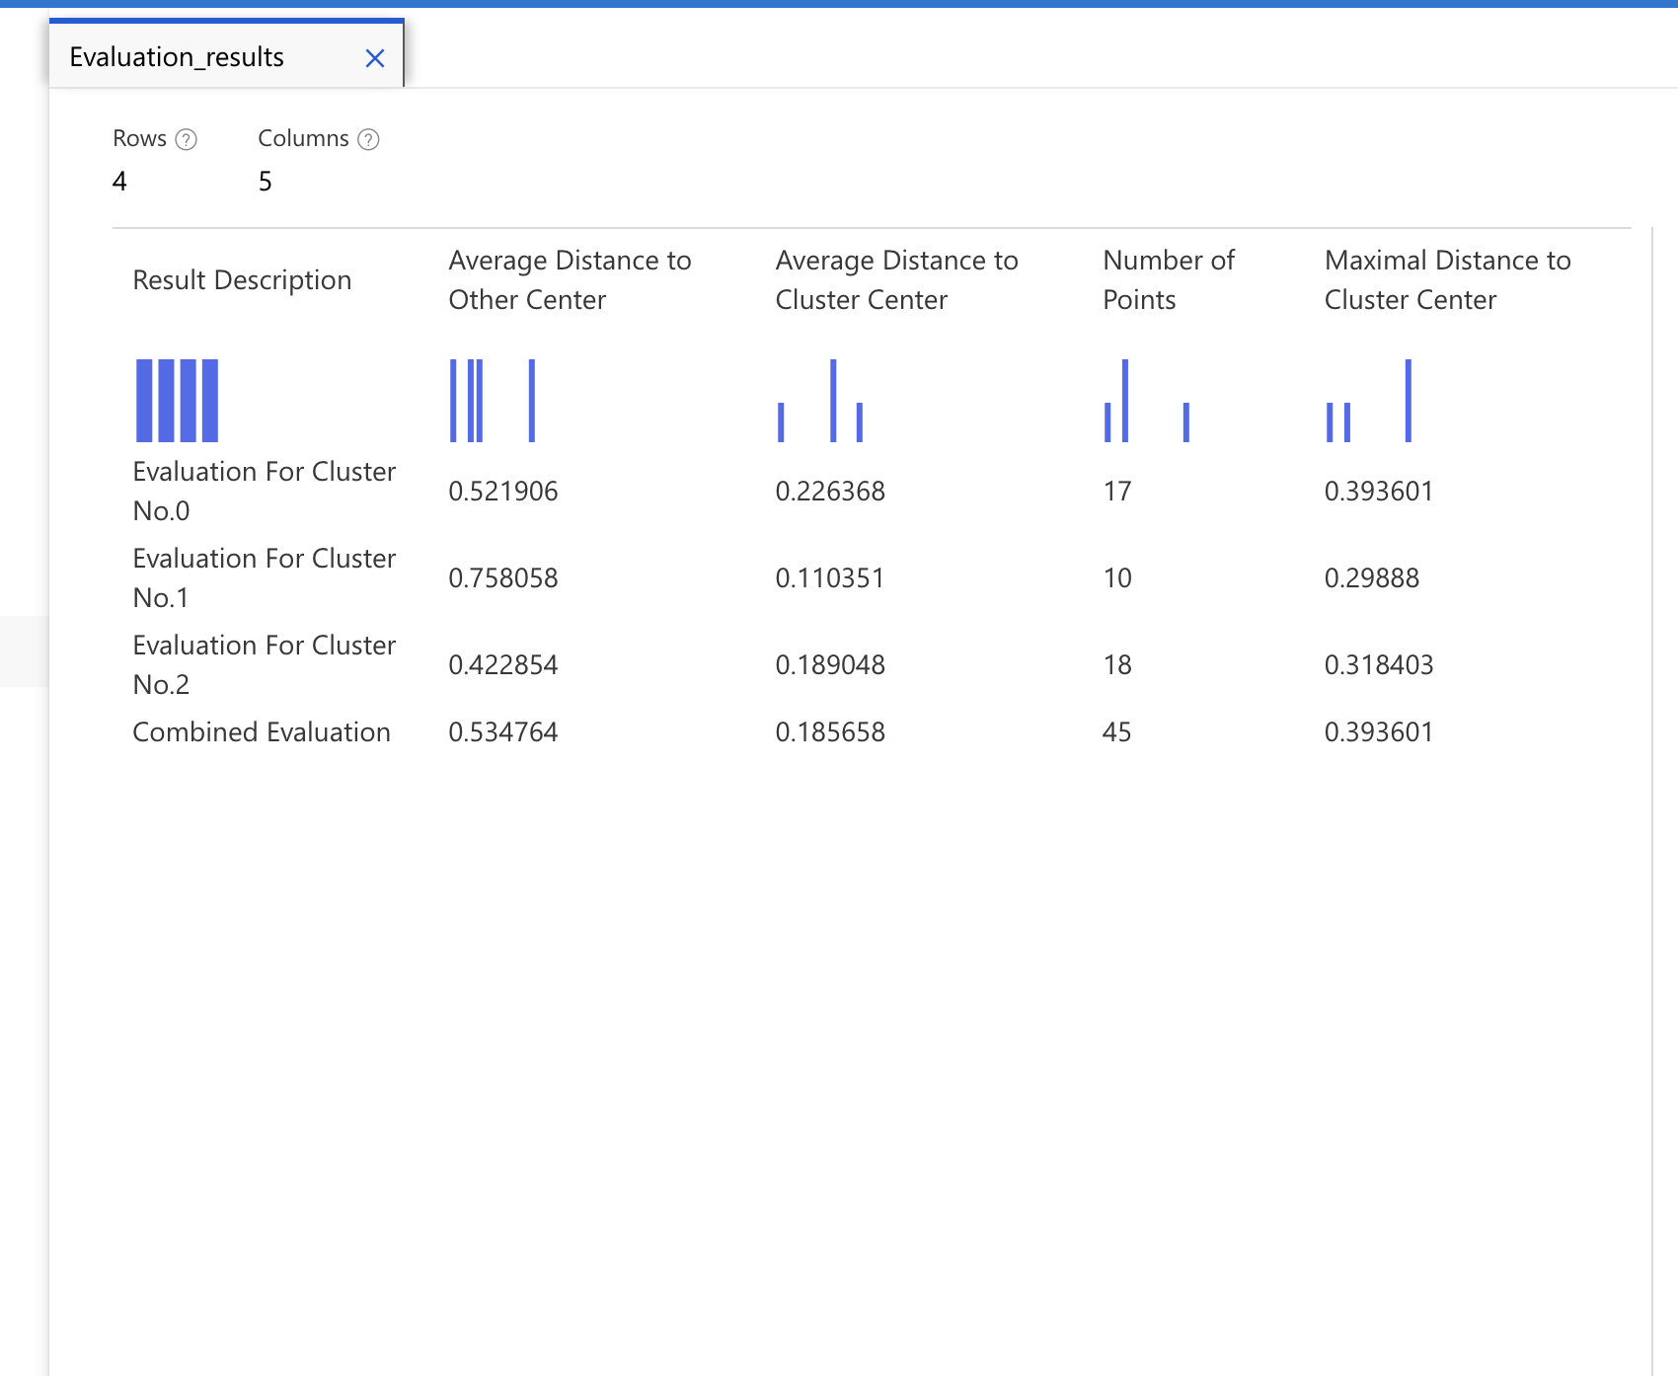

Figure 1.3

**Computer Vision- Wonders of The World**

The images below show a partial implication of this computer vision process using Mascroft azure services. This task provided me with 600 images representing selected landmarks from the initiative to develop an image classification pipeline. By choosing only 3 landmarks and reserving 10% of the images for testing.

Figure 1 shows the start of the process. Using custom vision, I started a project and chose my 3 landmarks which are Taj Mahal, Burj Khalifa and Eiffel tower in which I save 10% of the images for testing purposes. The first literation shows the first part of training which showed very good results The result shows that using image classification the custom vision can identify the landmarks.

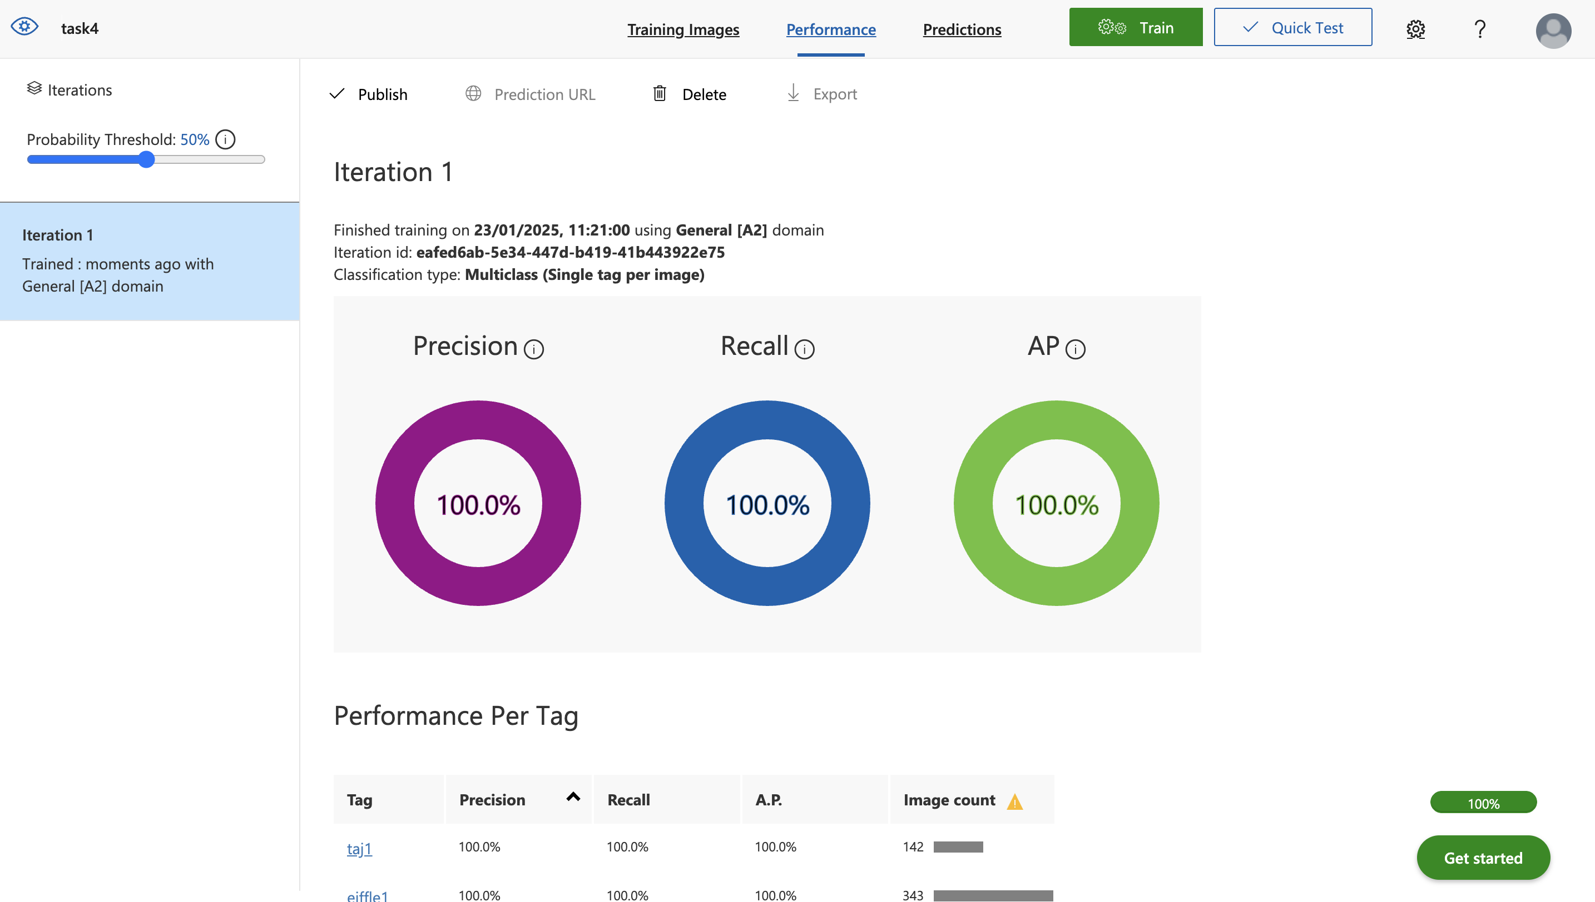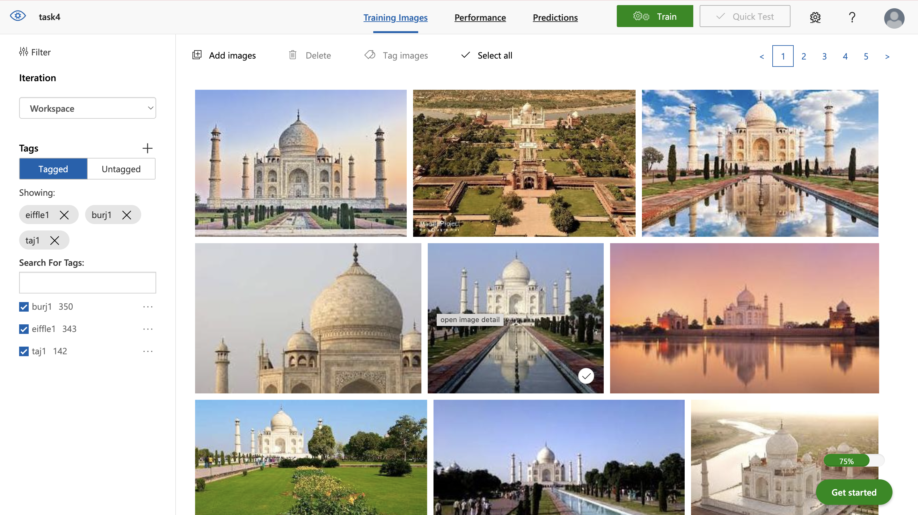

Figure 1

Figure 1.2 highlights the second part of the process which is for testing. In this I only used the 10% as it is for testing purposes. The results are lower than the first literation but yet good. Which shows the custom vision project succeed.

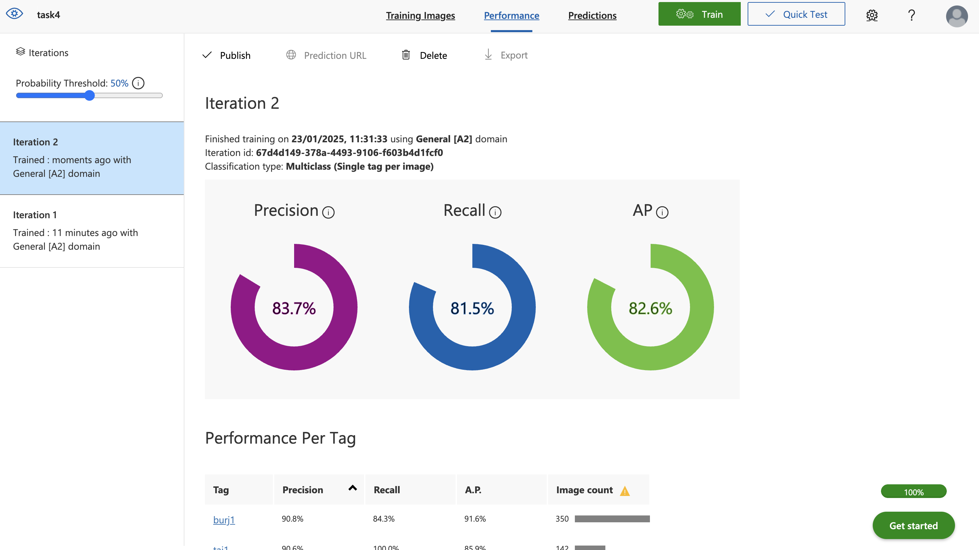

Figure 1.2

**References**

Bzovsky, S., Phillips, M.R., Guymer, R.H. et al., 2022. The clinician’s guide to interpreting a regression analysis. *Eye*, 36, pp. 1715–1717. Available from: <https://doi.org/10.1038/s41433-022-01949-z> (Accessed: 13th of December 2024).

Black, J.E., Kueper, J.K. and Williamson, T.S., 2023. An introduction to machine learning for classification and prediction. *Family practice*, *40*(1), pp.200-204.

**Dremio** (n.d.) *Univariate and Multivariate Analysis* [Online] Available from: https://www.dremio.com/wiki/univariate-and-multivariate-analysis/ (Accessed: from 13th of December 2024).

GeeksforGeeks (n.d.) *Clustering in Machine Learning* [Online] Available from: <https://www.geeksforgeeks.org/clustering-in-machine-learning/> (Accessed 28th of January 2025).

IBM (n.d.) *Classification in machine learning: A guide to algorithms and applications* [Online] Available from: <https://www.ibm.com/think/topics/classification-machine-learning#:~:text=A%20classification%20model%20is%20a,according%20to%20those%20learned%20characteristics> (Accessed: 22nd of January 2025).

Javatpoint. (n.d.). *Classification vs clustering in data mining*. [Online] Available from: <https://www.javatpoint.com/classification-vs-clustering-in-data-mining> (Accessed: 22nd of January 2025)

**Kahane, L.H*.***, 2007. *Regression basics*. Sage publications.

**Scribbr** (n.d.) *What is the difference between classification and regression in supervised machine learning?* [Online] Available from: <https://www.scribbr.com/frequently-asked-questions/what-is-the-difference-between-classification-and-regression-in-supervised-machine-learning/#:~:text=The%20difference%20is%20that%20classification,%2C%20income%2C%20or%20temperature> (Accessed: 22nd of January 2025)